Battle of the Neighborhoods: Tokyo Restaurants and Coffee Shops

By: Jason Robson

* Methodology section which represents the main component of the report where you discuss and describe any exploratory data analysis that you did, any inferential statistical testing that you performed, if any, and what machine learnings were used and why.
* Results section where you discuss the results.
* Discussion section where you discuss any observations you noted and any recommendations you can make based on the results.
* Conclusion section where you conclude the report.

Tables of Contents

1. Introduction
2. Data Description
3. Methodology
4. Results
5. Discussion
6. Conclusion

**Introduction:**

Kentaro is a financial adviser for Fujitsu and recently moved to an apartment in Tokyo, Japan. Kentaro recently had success in the stock market and wants to leave the telecommunication business. Kentaro wants to open new restaurant or coffee shop in the Tokyo area. If the business is successful, Kentaro plans to leave Fujitsu and devote his time to the new business. Kentaro doesn’t know where to begin. When he walks the streets of Tokyo, he sees all kinds of different restaurants and coffee shops. He wants to develop an idea of what types of restaurants and coffee shops are common in Tokyo special wards. Tokyo, Japan has 23 special wards. Kentaro wants to know what ward to open his business in and what type of business he should open.

**Data Description:**

The type of data selected for Kentaro consists of Tokyo, Japan special wards. This data will be acquired from a Wikipedia page: <https://en.wikipedia.org/wiki/Special_wards_of_Tokyo#List_of_special_wards> Data will be collected on special ward name, population, density, area, and major districts. (Table 1) This information will be used to collect information on the various coffee shops and restaurants in a specific ward using Foursquare. The information will be clustered based on the results. A suggestion will be made whether Kentaro should open a coffee shop or restaurant and where he should open it.

Table 1. Tokyo, Japan Special Wards

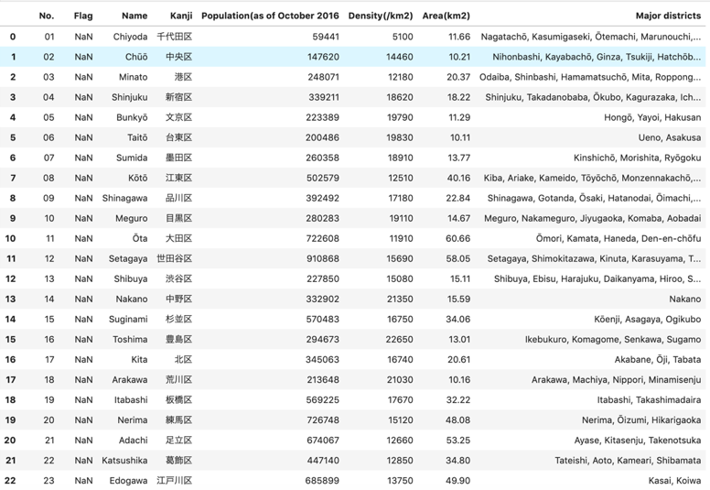

Special Wards of Toyko, Japan and their population, area, density, area, and major districts.